
Holy Cross College

Semester 1 Examination 2019

Question/Answer Booklet

Please place your student identification label in this box
Year 10 Chemistry
Modified

Student Name
Student’s Teacher

Time allowed for this paper

Reading time before commencing work: 5 minutes
Working time for paper: 30 minutes

Materials required/recommended for this paper

To be provided by the supervisor

This Question/Answer Booklet
Data Sheet

To be provided by the candidate

Standard items: pens, pencils, eraser, correction fluid, ruler, highlighters.
Special items: non-programmable calculators satisfying the conditions set by the School Curriculum and Standards Authority for this course.

Important note to candidates

No other items may be taken into the examination room. It is your responsibility to ensure that you do not have any unauthorised notes or other items of a non-personal nature in the examination room. If you have any unauthorised material with you, hand it to the supervisor before reading any further.

Structure of this paper

Section | Number of questions available | Number of questions to be answered | Suggested working time  (minutes) | Marks available | Percentage of exam
Section One:  Multiple Choice | 10 | 10 | 5 | 5 | 22.22
Section Two:  Short Answer | 5 | 5 | 15 | 15 | 33.33
Section Three:  Comprehension | 1 | 1 | 10 | 25 | 44.44
 |  |  |  | 45 | 100

Instructions to candidates

1. The rules for the conduct of examinations at Holy Cross College are detailed in the College
Examination Policy. Sitting this examination implies that you agree to abide by these rules.

2. Write your answers in this Question/Answer Booklet.

3. Working or reasoning should be clearly shown when calculating or estimating answers.

4. You must be careful to confine your responses to the specific questions asked and to follow
any instructions that are specific to a particular question.

5. Spare pages are included at the end of this booklet. They can be used for planning your
responses and/or as additional space if required to continue an answer.

• Planning: If you use the spare pages for planning, indicate this clearly at the top of the
page.
• Continuing an answer: If you need to use the space to continue an answer, indicate in
the original answer space where the answer is continued, i.e. give the page number.
Fill in the number of the question(s) that you are continuing to answer at the top of the
page.

SECTION 1 MULTIPLE CHOICE (10 marks)

1. Which of the following are non-metals?

(a) sodium.
(b) aluminium
(c) sulfur
(d) lithium

2. Which group of elements are called halogens?

(a) 1
(b) 2
(c) 17
(d) 18

3. A pure substance:

(a) is made of only 1 type of atom
(b) has 2 or more elements chemical combined
(c) is made of only 1 type of particle
(d) is also known as a compound

4. The element sodium is an example of:

(a) an alkali metal.
(b) an alkaline earth metal.
(c) a halogen.
(d) a noble gas.

5. A covalent bond will form between:

(a) 2 different metals
(b) a metal and a non-metal
(c) non-metals only
(d) a pure metal

SECTION 2 SHORT ANSWER (15 marks)

Attempt all questions. Write your answers in the spaces provided.

11. Classify each of the elements as either metals, non-metals or metalloids. (5 marks)

Mg, C, As, Kr, Fe, N, H, Al, Cu, B

Metal | Non-metal | Metalloid

12. Complete the following table showing the number of particles of each element.
(7 marks)

Element Name | Element symbol | Atomic number | Mass number | Number of Protons | Number of Neutrons | Number of Electrons
Carbon |  |  | 12
Calcium |  | 20 |  |  | 20
 | H | 1 | 2

13. List THREE properties of metals. (3 marks)

___________________________________________________________________________

___________________________________________________________________________

___________________________________________________________________________

SECTION 3 EXTENDED ANSWERS (25 marks)

Attempt all questions. Write your answers in the spaces provided.

14. The diagram below represents an atom of an element.

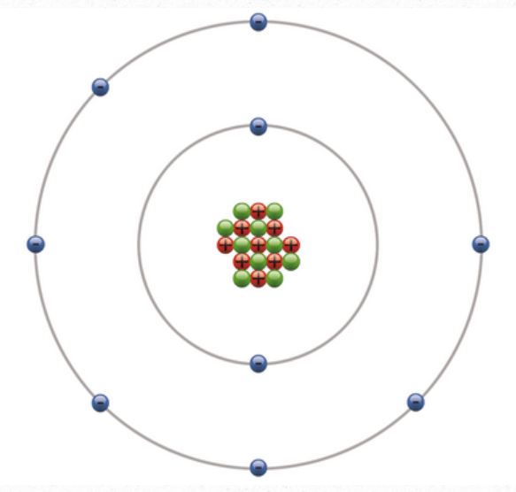

a. Label the protons, electrons and neutrons on the diagram. (3 marks)

b. What is the: (2 marks)

i. Atomic number? ____________________________________________________

ii. Mass number? _____________________________________________________

c. Name the elements represented. (1 mark)

______________________________________________________________________

d. What group on the periodic table is this element found in? (1 mark)

______________________________________________________________________

e. This element is described as:

“A very pale yellow-green, dangerously reactive gas. It is the most reactive of all the elements and quickly attacks all metals. Steel wool bursts into flames when exposed to fluorine.” (rsc, 2019)

Explain why the element is a gas. (3 marks)

______________________________________________________________________

______________________________________________________________________

______________________________________________________________________

______________________________________________________________________

______________________________________________________________________

______________________________________________________________________

______________________________________________________________________

______________________________________________________________________

______________________________________________________________________

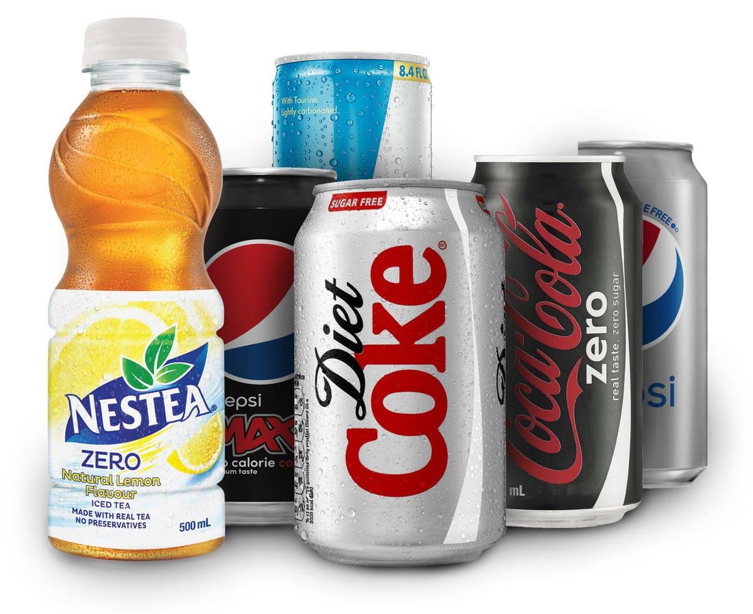
16. Aluminium is used to make soft drink cans.

a. Is aluminium a pure substance or a mixture? (1 mark)

___________________________________________

b. State the type of bonding in aluminium (metallic, covalent or ionic). (1 mark)

___________________________________________________________________________

c. One property that makes aluminium suitable to make soft drink cans is its malleability.

i. Define malleability. (1 mark)
___________________________________________________________________________

___________________________________________________________________________

ii. Explain why it is important for aluminium to be malleable if it is to be used in the production of cans. (2 marks)

___________________________________________________________________________

___________________________________________________________________________

___________________________________________________________________________

___________________________________________________________________________

iii. Describe one disadvantage of aluminium being malleable. (3 marks)

___________________________________________________________________________

___________________________________________________________________________

___________________________________________________________________________

___________________________________________________________________________

___________________________________________________________________________

___________________________________________________________________________

d. One alternative to using aluminium is plastic, which is a non-metal.

i. The formula for plastic is C₂H₄. Is plastic a compound or an element?
(1 mark)

___________________________________________________________________________

ii. What type of bonding (metallic, covalent or ionic) would be present in plastic? (1 mark)

___________________________________________________________________________

ii. Both containers are left outside on a hot day. What would be different about the 2 containers? (2 marks)

___________________________________________________________________________

___________________________________________________________________________

___________________________________________________________________________

___________________________________________________________________________

e. In your opinion, what is the best material to make a drink container from (it doesn’t have to be aluminium or plastic – you can consider all possibilities). Justify why you chose this material. (3 marks)

___________________________________________________________________________

___________________________________________________________________________

___________________________________________________________________________

___________________________________________________________________________

___________________________________________________________________________

___________________________________________________________________________

___________________________________________________________________________

___________________________________________________________________________

END OF EXAMINATION

